Programing Concepts - Tutorial 1 Solutions
HIT265 – C Programming
Question 1
Write a truth table for the following two C statements
!(!A&&!B) || C
A | B | C | (!A&&!B) | !(!A&& !B) | !(!A&&!B)||C
0 | 0 | 0 | 1 | 0 | 0
1 | 0 | 0 | 0 | 1 | 1
0 | 1 | 0 | 0 | 1 | 1
1 | 1 | 0 | 0 | 1 | 1
0 | 0 | 1 | 1 | 0 | 1
1 | 0 | 1 | 0 | 1 | 1
0 | 1 | 1 | 0 | 1 | 1
1 | 1 | 1 | 0 | 1 | 1

!(A||B) || C
A | B | C | (A||B) | !(A||B) | !(A||B) || C
0 | 0 | 0 | 0 | 1 | 1
1 | 0 | 0 | 1 | 0 | 0
0 | 1 | 0 | 1 | 0 | 0
1 | 1 | 0 | 1 | 0 | 0
0 | 0 | 1 | 0 | 1 | 1
1 | 0 | 1 | 1 | 0 | 1
0 | 1 | 1 | 1 | 0 | 1
1 | 1 | 1 | 1 | 0 | 1

Question 2
According to the definition of a graph, which graphs in Figure 1 are the same? Why?
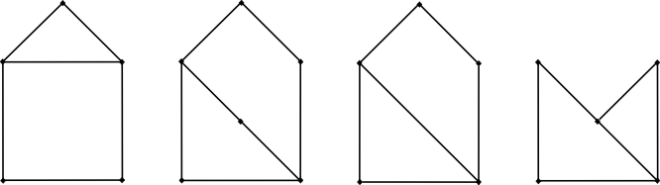

(a)
(b)
(c)
(d)

Figure 1
In Figure 1 the graphs (a), (c) and (d) are isomorphic.
Why? Graphs (a), (c) and (d) each have:
- 5 vertices, 6 edges,
- 3 vertices of degree 2, and
- 2 vertices of degree 3.
Remember these are necessary conditions; they are not sufficient to ensure isomorphism. We must also consider vertex adjacency. Each graph has 1 vertex of degree 2 which is adjacent to 2 vertices of degree 3; 2 vertices of degree 3 which are adjacent to each other and 2 vertices of degree 2; and 2 vertices of degree 3 which are adjacent to each other and a vertex of degree 2. Hence adjacency is preserved.
Figure 1(b) is not isomorphic to the other 3 graphs. It has order 6 whereas all other graphs have order 5.
Question 3
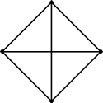
- Draw a complete graph with four vertices.
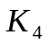

This is one possible representation of 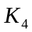.

- Draw a complete graph with five vertices.
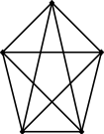
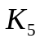

This is one possible
representation of 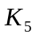.

- Draw a complete graph with six vertices.
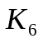
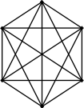

This is one possible
representation of 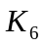.

- How many edges does 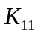 have?
Hopefully you didn’t try to draw this graph! Recall that in class we found that the total number of edges in 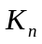 is given by:
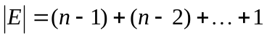 or 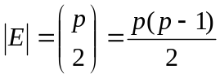, where 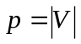.
Hence the size of the edge set of is:
or
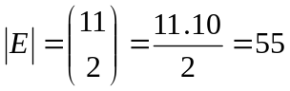
- What is the degree of each vertex in ?
Each of the n vertices in is adjacent to each of the other 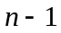 vertices in the graph. Therefore, each vertex in has degree .
Question 4
For each of the following, either draw a graph with the specified properties or explain why no such graph exists.
- A graph of order 5 with vertices of degree 0, 2, 2, 3 and 3. What is the size of the graph?
The following graph is one possible graph. Consider whether the graph you have drawn is isomorphic to this one.
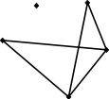

To calculate the size of the graph we can either manually count the edges of the graph drawn, or recall that for any graph G the total degree of the graph is given by 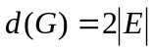. Therefore 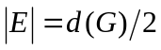. Hence the size of the graph is 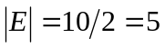.
- A simple graph with 6 vertices of degree 1, 2, 3, 3, 4 and 6.
This graph cannot be drawn because we cannot have a vertex of degree 6 in a simple graph of order 6. As we saw in Question 2 part (e), in a graph of order n, the maximum degree of any vertex is .
Note: Another way to check the validity of these parameters is to note that the total degree of any graph must be even. The sum of the degrees given above is 19. Therefore it is not a graph.
- A graph with 4 vertices and 8 edges.

The graph is of order 4 and size 8 (in other words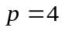 and 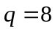). A complete graph of order 4 has only 6 edges (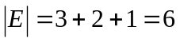), so there is no simple graph satisfying these parameters.
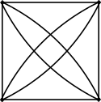
Some of you may have drawn a multigraph as a
solution to this. In this course we are interested primarily in simple graphs but in this case a multigraph is an acceptable answer. However if the underlying simple graph of your multigraph is not , you may want to rethink your answer (for instance, 2 vertices of the graph connected by 8 edges is not a good solution). 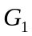 is an example of a multigraph with 4 vertices and 8 edges.
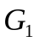


- 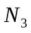.
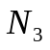
is a null graph of order 3.
- A bipartite graph 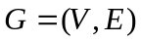, where 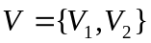. The order of the graph is given by 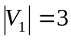 and 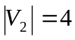, and the size is 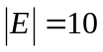.
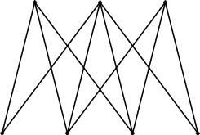
Below is one possible bipartite graph.

Question 5
A planar graph is a graph that can be drawn so that its edges intersect only at vertices. Figure 2 shows a connected planar graph, it divides the plane into two enclosed regions. Euler's Formula says that in any connected planar graph with p vertices, q edges, and r enclosed regions, p - q + r = 2.
Verify Euler's Formula for the graph in Figure 2.
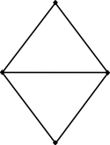
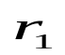
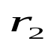

Figure 2
The order of the graph in Figure 2 is 4, therefore . The size of the graph is 5 and hence 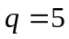. The graph has 2 interior regions, which I have labelled and 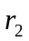 in Figure 2. There is also the exterior region, so r = 3.
Substituting the values for p, q and r into Euler’s formula gives:
4 - 5 + 3 = 2.
Hence Euler’s formula holds for the graph in Figure 2 as required.

